Homework M7: Monitoring and Observability
Main goal is to build further on what was demonstrated during the practice

Task
You are expected to execute the following
- Add a new metric to the API service, called tasks_completed_total of type counter
- Add a new metric to the API service, called tasks_active of type gauge
- Create a simple Grafana dashboard to display the three API metrics – tasks_created_total (created during the session), tasks_completed_total, and tasks_active

Proof
Prepare a document that shows what you accomplished and how you did it. It can include (not limited to):
- The commands (or code blocks) you used to achieve the above tasks
- A few pictures showing intermediary steps or results

1. Add a new metric to the API service, called tasks_completed_total of type counter
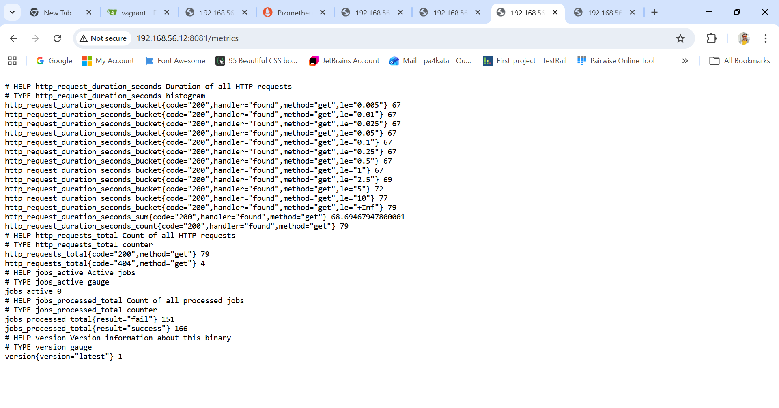
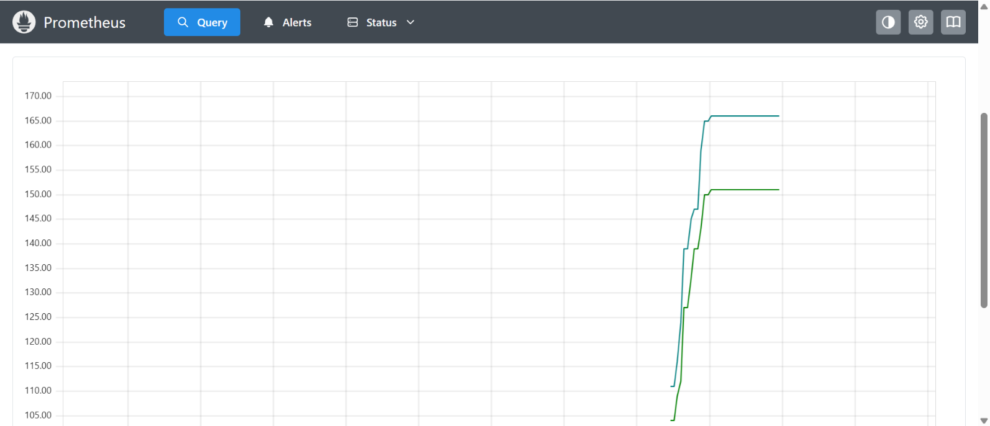2. Add a new metric to the API service, called tasks_active of type gauge
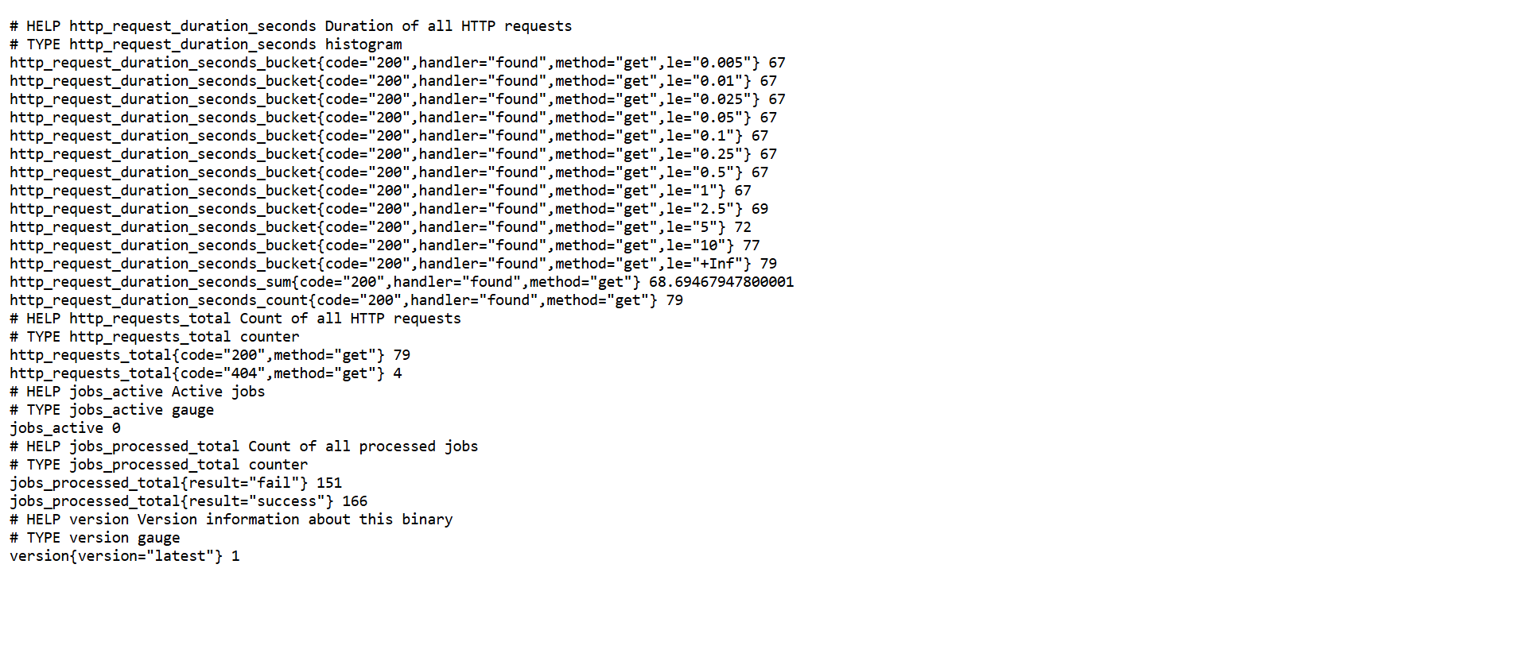
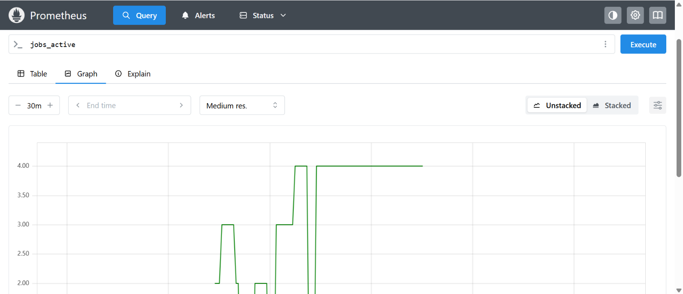
3. Create a simple Grafana dashboard to display the three API metrics – tasks_created_total (created during the session), tasks_completed_total, and tasks_active
3.1.task_completed_total
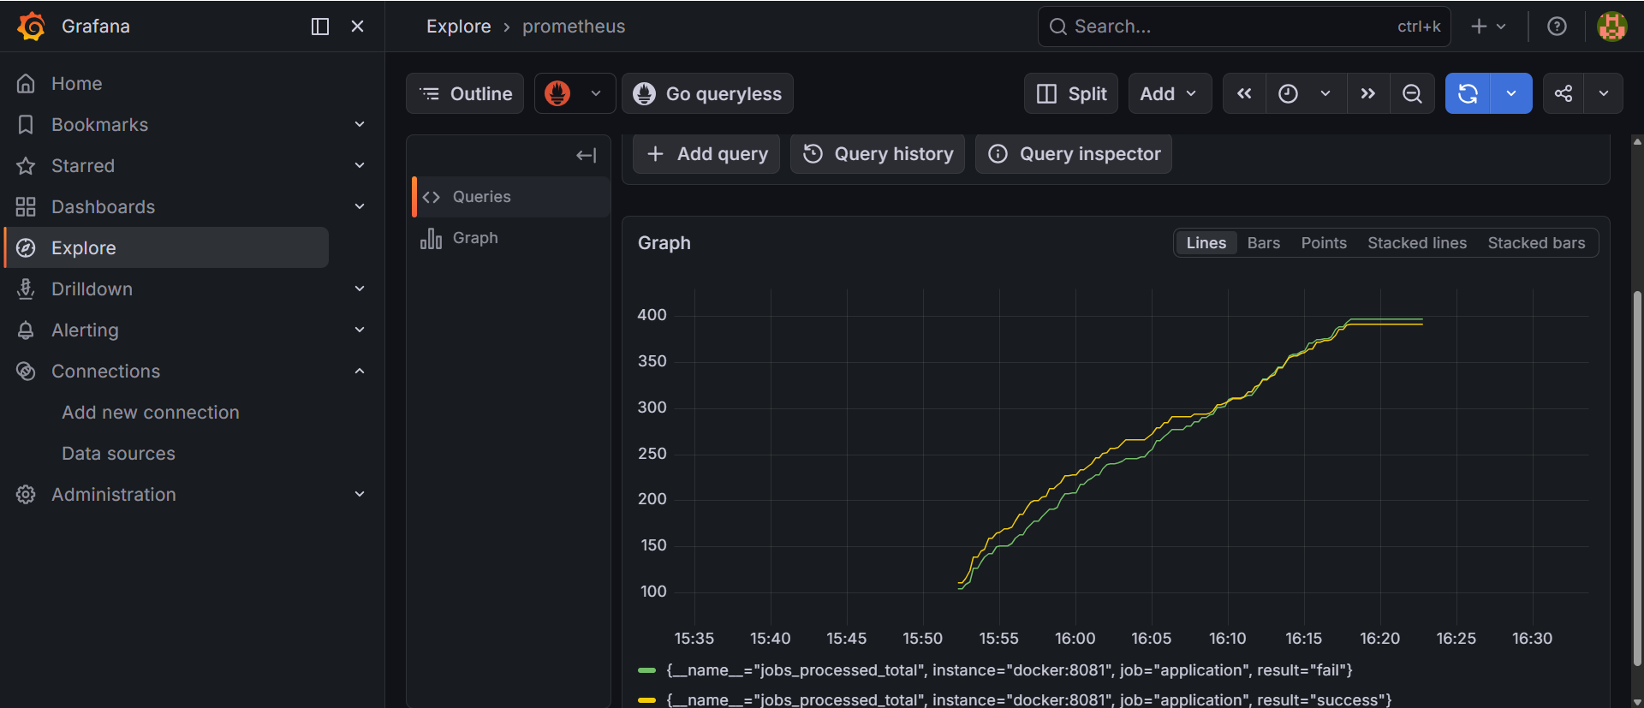
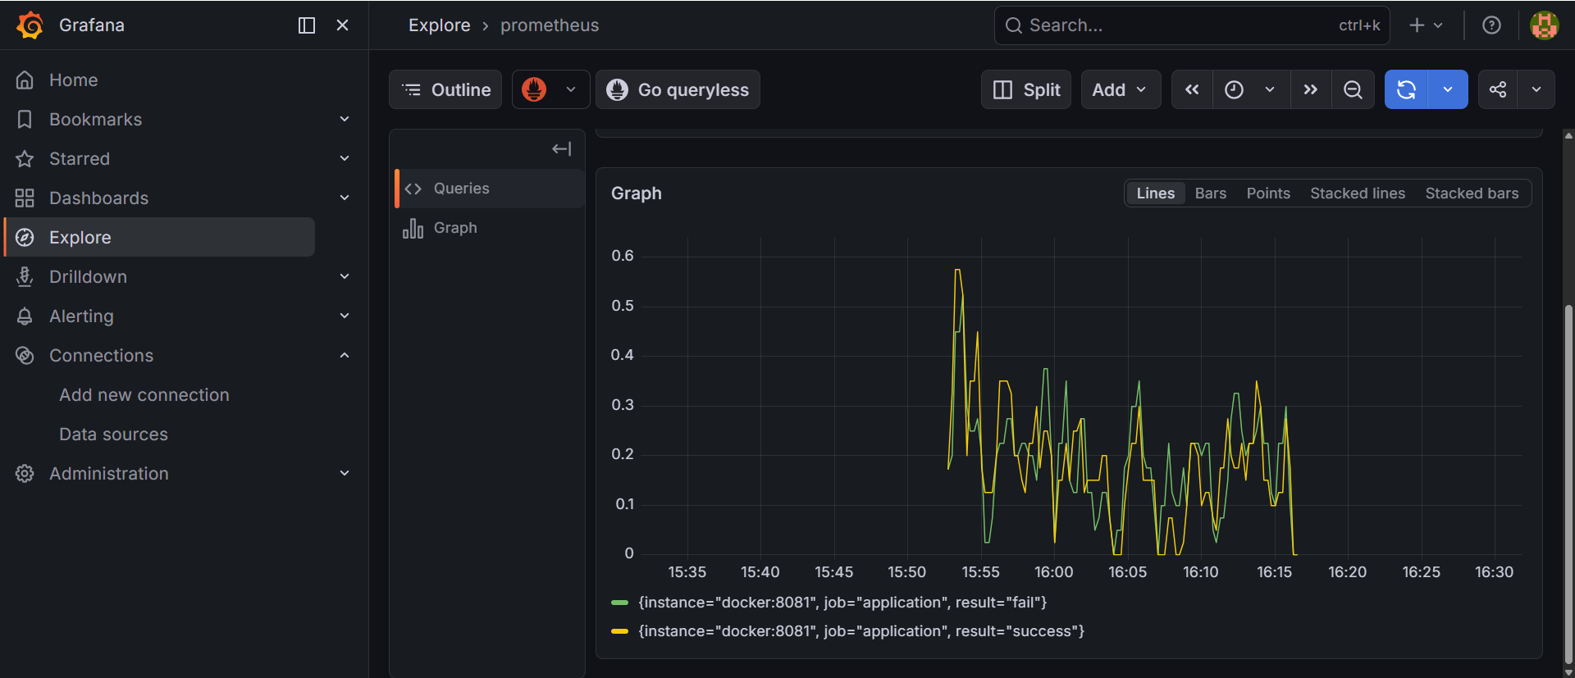
3.2.tasks_active
